Student Names: ______Walter Elmore________, ___________Will Simonar____________, ________________________

A Simple Amplifier
I. INTRODUCTION
In the world of electronics, the amplifier is one of the most important circuits. For this project you will build an amplifier and investigate some of its properties. Figure 1 is a schematic of an amplifier. A schematic is like a map that shows you how different components of a circuit are connected together. However, each part is represented by a symbol instead of a picture. For example, the triangle in Figure 1 represents an integrated circuit (IC) called an operational amplifier (op amp). The blue zig-zag lines represent an electrical element known as a resistor. The resistor with the arrow through it represents a resistor with a variable value. The red lines represent wires. The blue long and short stacked dashes represent power supplies. Figure 2 is pin layout of the actual op amp that shows how the electrical connections are made to the chip.
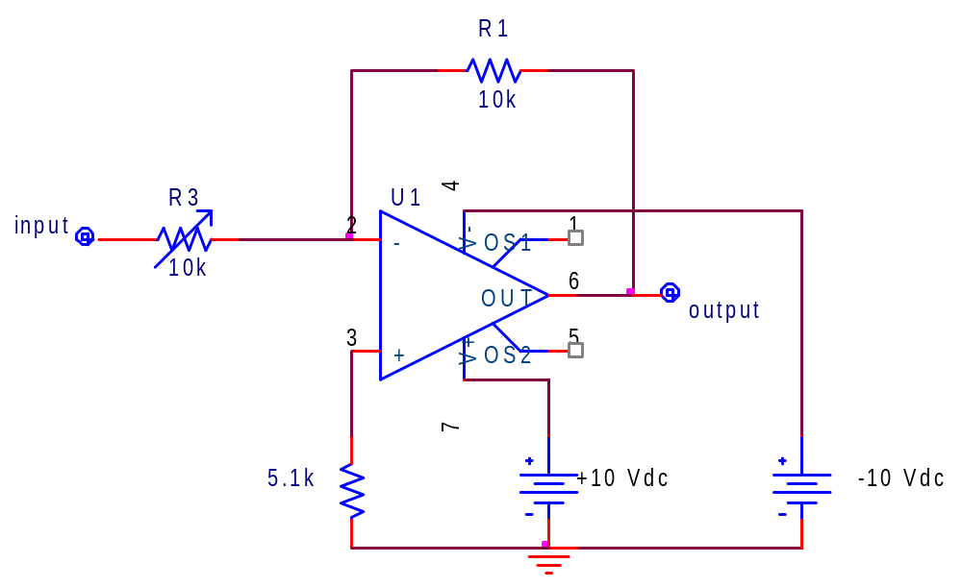
Figure 1. The schematic of an operational amplifier based voltage amplifier. This schematic was developed in an electrical circuit computer aided design (CAD) program called PSpice.
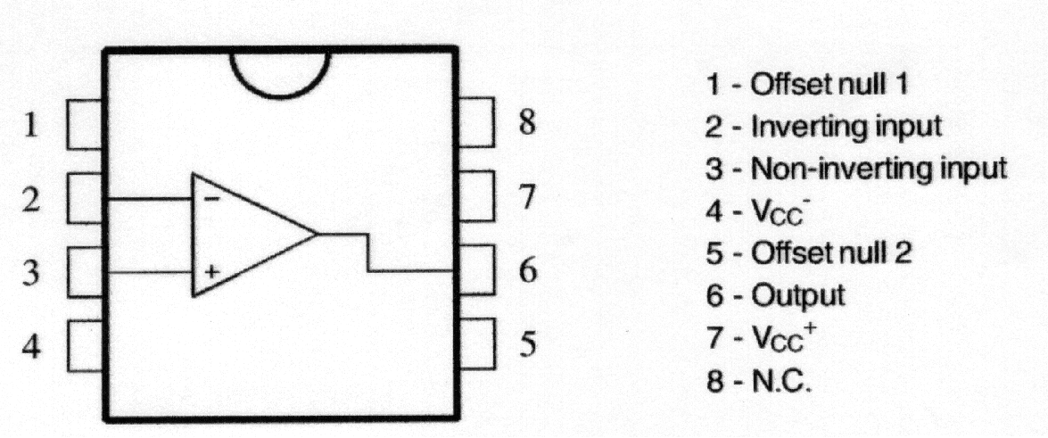
Figure 2. The connections to the op amp are mapped out on a rectangle that more closely resembles the actual chip. The numbers next to each “pin” in this figure correspond to the numbers associated with the schematic representation in Figure 1. Pin 4 should be connected to the -20 V terminal of the power supply. Pin 7 should be connected to the +20 V terminal of the power supply. Note that the little half circle at the top represents the little “divit” on one end of the actual chip. Some chips have a small circle in the corner next to pin 1.

II. PROCEDURE
In part I of the project you will build this cicuit on a prototyping board called a breadboard. In the part II of the project you will use a DC power supply, a signal generator, and an oscilloscope to investigate some of the things that this circuit can do.

Part I. Prototyping the Circuit Schematic Using Breadboard
- Receive parts needed from your instructor, you need three resistors (a 10kohm resitor, a 5.1kohm resistor and a button-like variable resistor (also called a potentiometer), one OpAmp (the chip with 8 pins), a speaker, a breadboard and some wires. If you are not sure about the values of the resistors, use a DMM (digital multimeter) to measure them by yourself or ask your instructor for help.
- Breadboard the circuit schematic shown in Figure 1 using the given components. To help you prototyping the circuit, a detailed breadboarding diagram is shown in Figure 3. For your reference, a breadboard with the circuit already built is put on one the tables in the middle of the room. For now, only focus on the breadboard part and do not connect the dc power supply, the oscilloscope and the function generator to the breadboard yet.
- Make sure to turn the variable restor knob clockwise all the way to the end, which will allow the full 10k ohm resistor to be used in the circuit initially. Check Figure 3 for illustration as needed.
- Unscrew the red terminal post and use a wire that is stripped on each end to connect the terminal post to a long breadboard connective clip line for +10V and screw down the terminal post. Create a similar connection for the black terminal post for -10V and the green terminal post for COM.
- Double check your circuit and make sure it’s correctly connected. If everything is fine, contact the instructor to check your initial wiring.
Initial Wiring Checkoff ________ZR___4:30__________________________________

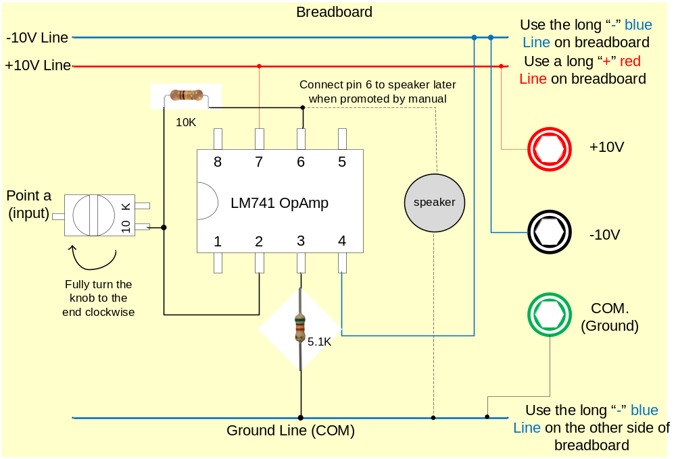
Figure 3. Illustration of prototyping the amplifier circuit schematic on the breadboard. Use separate long breadboard connective clip lines for +10V, -10V, and COM connections (whether or not your breadboard has blue or red line designation)
- Getting to know the test equipment
  - Agilent E3630A DC Power Supply:
    - Press the “+20 V” button under the word METER on the power supply.
    - Turn the “Tracking ratio” knob in the “VOLTAGE ADJUST” section on the power supply to the “Fixed” position.
    - Turn the “±20 V” knob all the way counter-clockwise.
    - Turn on the power supply.
    - Slowly turn the “±20 V” knob on the power supply clockwise until the LED on the power supply display reads 10 under the “VOLTS” label. The LED under the “AMPS” label should be 0.00 or 0.01.
    - Press the “-20 V” button on the power supply and verify that the power supply display reads about -10 under the “VOLTS” label.
    - Turn off the power supply.
  - Agilent Function/Arbitrary Waveform Generator
    - Turn on the waveform generator using the round white button with the green symbol on it.
    - Press the “Sine” button on the signal generator.
    - Press the dark gray toggle button under the “Freq/Period” label on the LCD screen so that the “Freq” is highlighted. Enter 1 on the keypad and press the button under the “kHz” label on the signal generator LCD screen.
    - Press the dark gray toggle button under the “Amplitude/HiLevel” label on the LCD screen so that “Ampl” is highlighted. Enter 100 on the keypad. Press the button under the “mVpp” label on the LCD screen. Observe the signal on the signal generator preview screen.
    - Press the “Output” button on the signal generator to toggle on and off the signal
    - Turn off the waveform generator using the round white button with the green symbol on it.
  - Tektronix Two-Channel Digital Oscilloscopes
    - Obtain 2 BNC test leads (black cables with the red and black clips on one end and the ridged metal connector on the other end) which are hanging on a rack near the end of a bench located in the center part of the lab.
    - Connect one BNC test lead to the BNC connector of channel 1 and the other to the BNC connector of channel 2.
    - Turn on the oscilloscope using the button on top of the unit.
    - Depress the red lead of the channel 1 test lead and connect it to the upper connection point under “PROBE COMP”.
    - Depress the black lead of the channel 1 test lead and connect it to the lower connection point under “PROBE COMP”.
    - Press the autoset button on the scope.
    - You should see one “trace” on the oscilloscope screen. A trace is the name we use for the data graphed on the screen. This trace should alternate between positive and negative square pulses (square wave)
    - Press the button under “CH 1 MENU”
    - Verify that Probe is set to 1X (change using toggle button if needed)
    - Press the measure button on the scope.
    - Use the “Source” toggle buttons to designate 2 of the readings for CH1 and 2 for CH 2
    - Use the “Type” toggle buttons to designate one of the CH1 readings as Pk-Pk and one of the CH2 readings as Pk-Pk. Designate the other CH1 and CH2 readings as Freq.
    - The CH1 reading designated as Pk-Pk should have a reading of roughly 5V (+/- 10%)
    - Repeat steps iv through xiii to verify correct operation of your oscilloscope channel 2 test lead.

Part 2. Circuit Testing

Equipment Set-up
- Read the following sentence about the Leads and cables:
The red, green, yelow, black, and white colored wires with bare metal ends hanging on the walls are called banana test “leads” (rhymes with deeds). The black cables with the red and black clips on one end and the ridged metal connector on the other end are called BNC test leads. The black cables with the ridged metal connector on both ends are called BNC to BNC cables. Get three different colors of banana test leads (red, yellow, green), three BNC test leads and one BNC-BNC cable from the racks on the walls/ends of the lab benches.

- Repeat Part 1 step 6a. (DC Power Supply Settings)

With the +20V button pushed the power supply display reads ____10.04_____ VOLTS

With the -20V button pushed the power supply display reads _____10.04____ VOLTS

- Repeat Part 1 step 6b. (Waveform Generator Settings – include value and units)

With the “Freq/Period” button pushed and “Freq” highlighted
the display reads: 1.000 kHz_________________________________

With the “Ampl/HiLevel” button pushed and “Ampl” highlighted
the display reads: __100mV_{pp}__________________________________________

With the “Offset/LoLevel” button pushed and “Offset” highlighted
the display reads: __+0.00V_{dc}____________________________________

- Repeat Part 1 step 6c. (Oscilloscope– include value and units)

With Channel 1 connected to “PROBE COMP”
the CH1 Pk-Pk display reads 5.28 V____________________________________

With Channel 2 connected to “PROBE COMP”
the CH2 Pk-Pk display reads __5.20V____________________________________

- Conecting power supply, function generator and osciloscope (Illustrated by Figure 4):
Attach the power supplies using the three different colored leads. Use a red lead for the +10 V supply (connected to the +20 terminal of the Agilent E3630A power supply), a yellow lead for the -10 V supply (connected to the -20 V terminal of the power supply) and a green lead for the common terminal (labeled COM on the power supply). Attach the three leads to the appropriate terminals of the power supply on the shelf above the bench. Attach the other end of the leads to the posts on the breadboard. Attach a wire from each of the three posts to the appropriate power-lines on the breadboard, the positive supply voltage goes to pin 7, the negative supply voltage goes to pin 4 and the COM goes to the “bottom” end of the resistor hanging off of pin 3. Now plug the BNC connectors into the signal generator terminal marked “Output” and CH 1 (channel one) and CH 2 of the oscilloscope. Attach all three of the black mini-grabbers to a wire connected to the common terminal of your circuit. Attach the red mini-grabber from the signal generator to the input of your circuit. Attach the red mini-grabber from channel one of the oscilloscope to the input of your circuit. Attach the red mini-grabber from channel two of the oscilloscope to the output of your circuit. Attach the BNC-BNC cable to the “Sync” terminal of the signal generator and to the “EXT TRIG” terminal of the scope. Ask the instructor to verify that you have made all of the connections properly.

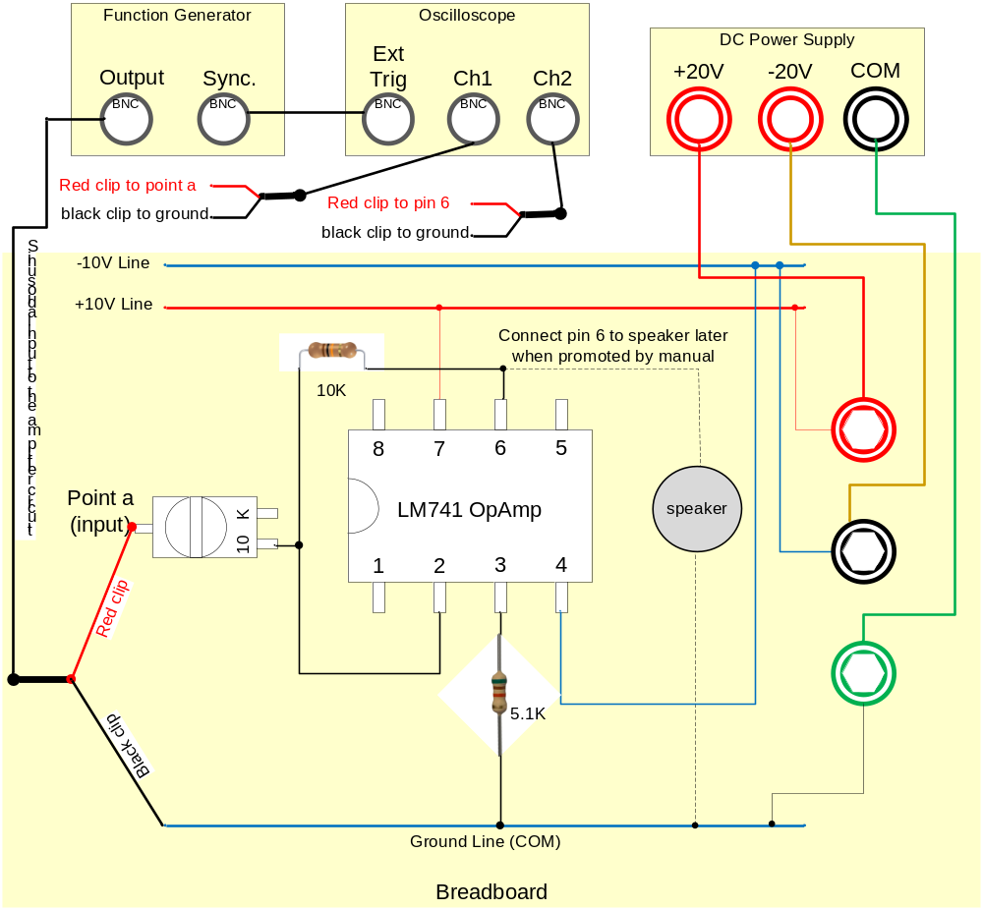
Figure 4. Lead connection diagram for testing the amplifier circuit.

Circuit Wiring Checkoff _______ZR_____3:40_______________________________________
With the instructor present turn on the power supply, signal generator, & oscilloscope.
Using the Wintek32 software (NOTE: this step will be repeated throughout the lab)
We use a simple application called Wintek32 to capture the oscilloscope screen as an image on the Windows clipboard. On the desktop of the computer on the bench you will find an icon for the Wintek32 application. Double-click the Wintek32 icon. You should see a dilogue box on the computer screen that says “listening on Com1”. Make sure that you tell Wintek you want the image to be saved to the clipboard. Press the STOP button on the scope. Now press the hardcopy button on the scope. The dialogue box on the computer will now say something like “downloading”. When the image has finished loading onto the computer, paste it in the space provided below. Use Word tools to resize and/or rotate it so it can fit into the space below. Press the RUN button on the scope.

- The oscilloscope setups:
Press the autoset button on the scope. You should now see two traces on the scope screen. One is the input signal on channel one and the other is the output signal on channel two. Use the vertical “POSITION” knobs above “CH 1” and “CH 2” to move the traces up and down so that you can see both clearly. Move the trace for channel 1 above the trace for channel 2. If your circuit is correctly configured, you should see two sinusodal waveforms with the same “amplitude” and “frequency” but inverted. You should also have CH1 Pk-Pk and CH2 Pk-Pk values indicated on the right-hand side of the display. Use the Wintek32 software to record your first oscilloscope image in the space below:
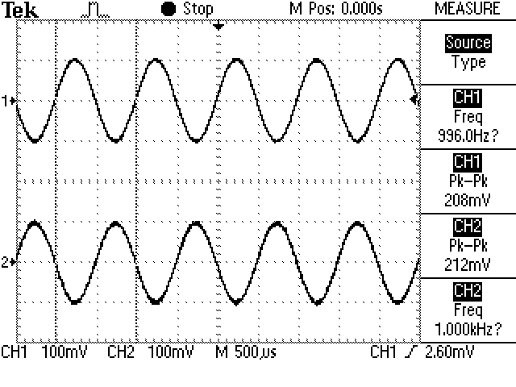

Press the button next to the “Invert” label on the scope screen so that it is “On”, which will invert the signal so both channels show almost identical signals. At this moment, the amplifier is set to have a gain of 1. Note, if you couldn’t get two identical sinusoidal signals as discribed above, you may have a problem with your circuit setup. Check if your variable resistor is at the right location. If problem persist, ask your instructor for advice before moving on. Use the Wintek32 software to record your 2nd oscilloscope image in the space below:

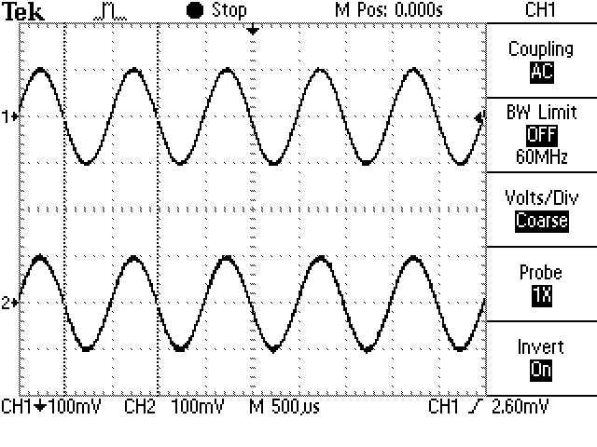

- Measuring with an oscilloscope:
Press the “CH 1” one button above the CH 1 knob. Press the “MEASURE” button near the top of the scope. On the right-hand part of the scope screen you should see a series of numbers and words. Record the voltage and frequency measured on each channel (include units). Press the button next to the “Freq” label for each channel until it reads “Period”. Record the period measured on each channel (include units).

 | Peak-Peak Voltage | Frequency | Period
CH 1 | 208mV | 1.002 kHz | 998µs
CH 2 | 212mV | 1.002 kHz | 998µs

- The amplifier:
Carefully and slowly rotate the variable resistor knob on the circuit. This will reduce the amount of the resistance of the variable resistor. While reducing the resistance, the gain of the amplifier will increase and the output amplitude will be amplified. Observe the relationship between the oscilloscope traces on channel one and channel two as you rotate the knob. When the output increases beyond the screen of the scope, turn the channel 2 “VOLTS/DIV” knob counter-clockwise until the output is fully on the screen.
Record the data using 3 different knob positions in the table below (include values and units as they appear on the oscilloscope display) Make sure the output on channel 2 is still a undistored sinusodal waveform. Include two screen captures which correspond to two of the three knob positions in the table below. Make sure to keep track of the effect that the amplifier has on the amplitude and the frequency of the output.

3rd oscilloscope image:
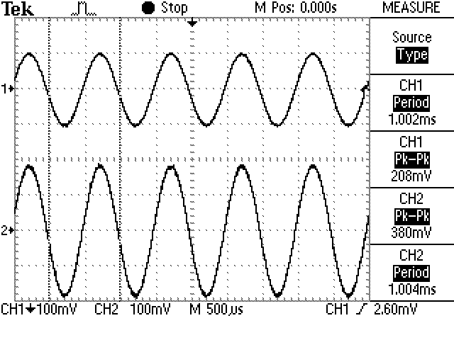

4th oscilloscope image:

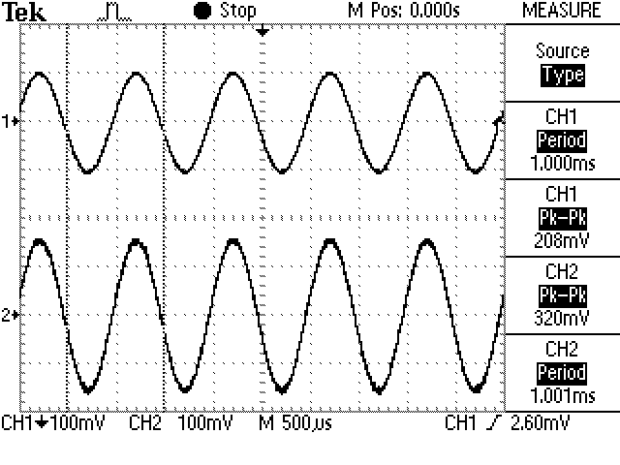

Trial # | Ch 1 Pk-Pk | Ch 2 Pk-Pk | Ch 1 Freq | Ch 2 Freq | Ch 1 Period | Ch 2 Period
1 | 208 mV | 380 mV | 998.0 Hz | 1.003 kHz | 1.002 ms | 997.0 µs
2 | 208 mV | 320mV | 1,000 Hz | 999 Hz | 1000 ms | 1.001 ms
3 | 208 mV | 224 mV | 996.0 Hz | 1000 Hz | 1.004 ms | 1.000 ms

Use complete, typed sentences (2-3) to record your observations in the space below about the relationship of the characteristics of the two waves to each other as you adjust the amplifier’s variable resistance knob.

Only Ch 2 measurments changed as we affected the variable resistance knob. As the resistance increased the measured voltage on Ch 2 decreased but the period and frequncey stayed the same.

- High Amplitude signals:
Adjust the knob position until the output on channel 2 is no longer sinusoidal. Include a screen capture below.

5th oscilloscope image:

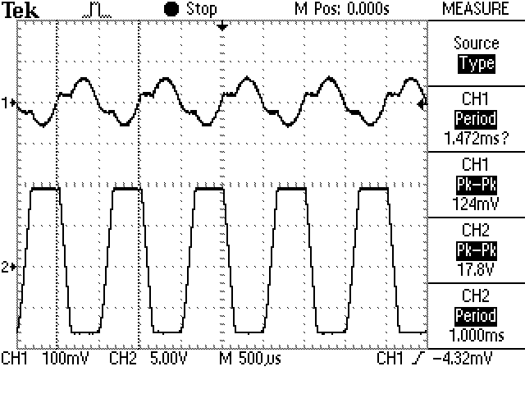

- Connecting the speaker:
Turn the amplifier’s variable resistor back fully clockwise to its minimum gain of 1, (10kohm for the variable resistor),. Turn off the power supply. Connect the + lead of the speaker (usually the longer lead) to the output terminal and the other lead of the speaker to the common line. Turn on the power supply. You should hear a faint pure tone coming from the speaker. If not slowly turn the knob on the variable resistor until you start to hear the faint pure tone. Save an oscilloscope capture in the space below that corresponds to this initial variable resistor setting.

6th oscilloscope image:

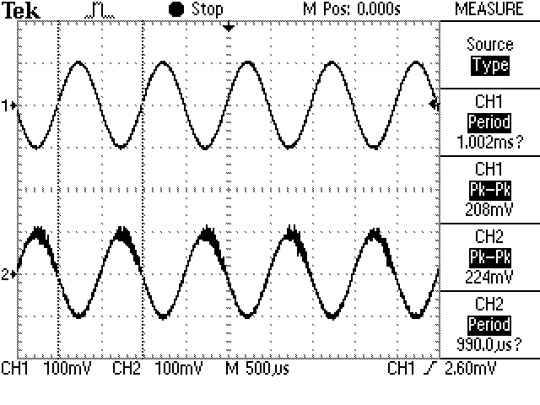

- Sound and amplitude:
Carefully and slowly turn the knob on the variable resistor and listen to the changes in the sound. When the output signal on the scope gets too big for the screen turn the CH 2 “VOLTS/DIV” knob counter-clockwise until you see the whole output waveform again. Continue increasing the output amplitude by turning the variable resistor knob until the sound quality begins to change. Notice that the trace on the oscilloscope also changes at about the same time. Record your observations in complete sentences and a screen capture using Wintek32 that help describe what happens to the waveform on the scope when the sound quality begins to change. Also describe the relationship between amplitude and loudness..

7th oscilloscope image:

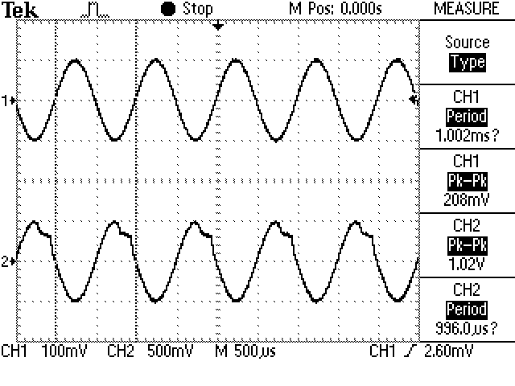

observations

As the resistance decreased on the variabel resistor the volume of the speaker increased.
The Shape of the graph became not as smooth of a curve.

Continue to turn up the volume of the amplifier until you can no longer increase it. Record your observations in words and a screen capture using Wintek32 that help describe what happens to the waveform on the scope when the variable resistance knob is turned all the way up. Put the screen capture images here and use complete, typed sentences to record your observations about the waveform when the variable resistance knob is turned all the way up.

8th oscilloscope image:

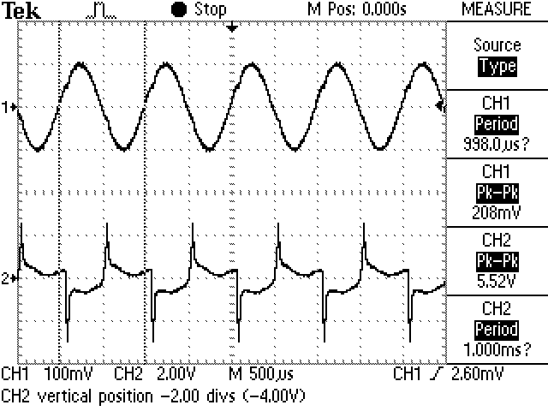

observations

The volume continued to incresas and the shape of the curve became more jagged.

What you are seeing on the scope screen is a messed up version of the sinusoidal signal. What has happened here is that we have asked the amplifier to deliver an output loudness that it can’t achieve. As a result the semiconductor electronics in the op amp go into a non-linear mode and can sometimes even begin to oscillate or “vibrate in an electrical way” causing these distortions. We have attempted to make the amplifier drive the speaker beyond the capabilities of the amplifier. What you are hearing is the “harmonic distortion” caused by these nonlinear effects.

Turn the variable resistor knob back to reduce the amplifier gain so the output wave shown on channel 2 return to a sinusoidal shape and at the same time you can still hear a clear sound.

- Sound and frequency:
Press the “Freq” button on the signal generator. Adjusting the input frequency by turning the knob on the signal generator and listen to the sound from the speaker. Record your observations in words and two screen captures (frequency 1 and frequency 2) using Wintek32 that help describe what happens to the waveform on the scope and how the images of the traces and the frequency of the traces relate to the pitch of the sound you hear. Put the screen capture images here and use complete, typed sentences to record your observations about the frequency and pitch.

9th oscilloscope image:

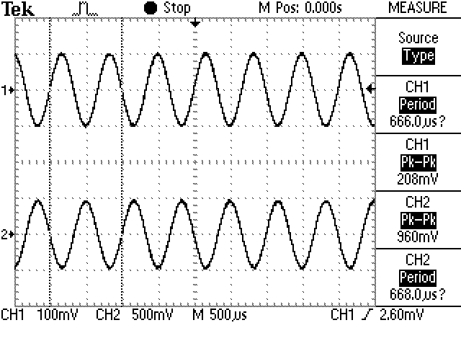

10th oscilloscope image:

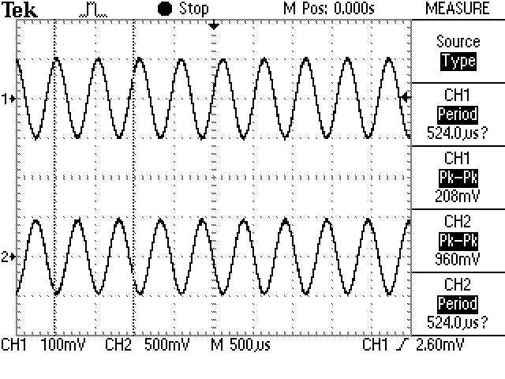

Observations
The period of the wave decreased causeing the pitch of the tone from the speeker increased.

- Clean up:
Turn off the power supply, signal generator, and oscilloscope.
Verify that you have collected all the needed information for this lab.
Look over the post lab questions. Make sure that you have taken the data needed to properly answer these questions.

If so, you can return all the leads to the appropriate racks. Disassemble your circuit and put the parts back in the appropriate containers.
III. Post-Lab Questionaries (6 questions in total)
Based on the tests you have performed, use complete sentences and relate your observations to the questions below.
- Describe the affect of the amplifier on the input and output amplitudes and frequencies as you change the variable resistance knob on the amplifier. Answer the question through the following subquestions.
- Does the amplitude of the output change when you turn the knob on the variable resistor? (be specific)

Your answer:

- Does the amplitude of the input change when you turn the knob on the variable resistor? (be specific)

Your answer:

- Does the frequency of the output change when you turn the knob on the variable resistor? (be specific)

Your answer:

- Does the input frequency change when you turn the knob on the variable resistor? (be specific)

Your answer:

- What is the relationship between amplitude and loudness? (be specific)

Your answer:

- What is the relationship between pitch and frequency? (be specific)

Your answer:

- What is the relationship between frequency and period? (be specific)

Your answer:

- Find a definition of clipping (regarding the clipping effect to the output of the electronics devices) on the web. How does this relate to this lab project?
Your answer:

- Find a definition of distortion on the web. How does this relate to this lab project?

Your answer:

IV. SUBMISSION

After you have finished all the requirments of the projects, please upload your report to the D2L dropbox. Name your report using the following format:

Sec#_FullName1_FullName2_FullName3.doc

Each group will upload only one copy under one of the team member’s name. Make sure all of your names are included in the first page and in the file name. The due date is Friday of the week you do the module (see drop box).

Congratulations! You have accomplished the EE module. To learn more about UWP’s EE program, you may take EE1020 Introduction to Electrical Engineering Project and Tools.

